How to get Logs from testing/debug version of SurfSafeVPN

- Manual
By default all 1.5 builds of SurfSafeVPN store logs in the. /Library/Application Support/SurfSafeVPN/Logs. You could get access to this folder and copy log files.

1. On the main menu of finder select "GO->Go to folder..."
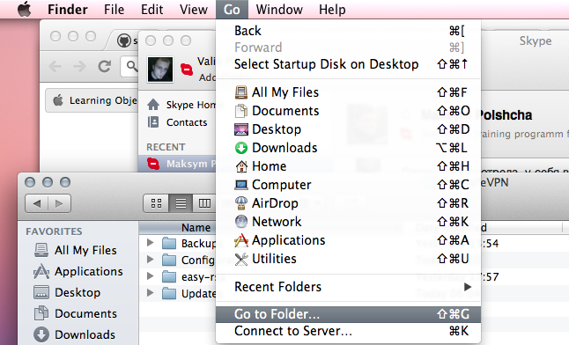
- Enter /Library/Application Support/SurfSafeVPN/ in the pop-up window
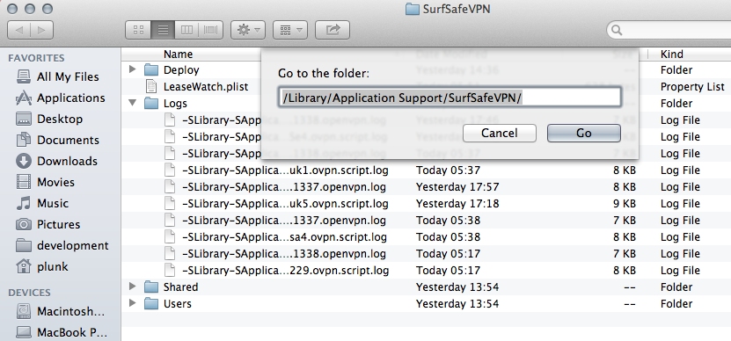
3. Check folder structure
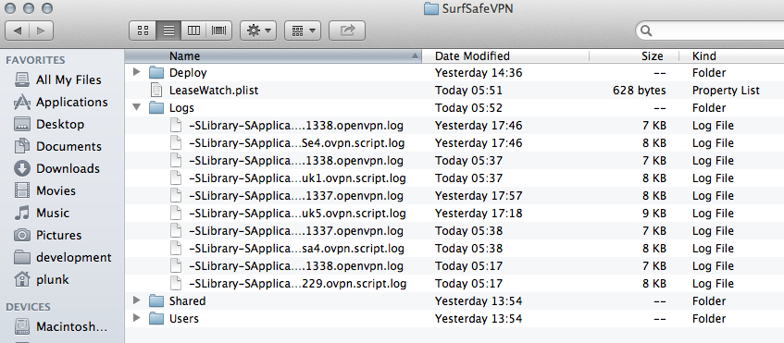
Please copy all files from /Library/Application Support/SurfSafeVPN/Logs/ and send them to SurfSafeVPN support.

- Automatic
Some testing versions of SurfSafeVPN allow user to get logs in semi-automatic mode
1. run surfsafevpn. Please take screenshots of all error pop-up windows and send them to me.
2. select menu item "vpn details" (pic 2)
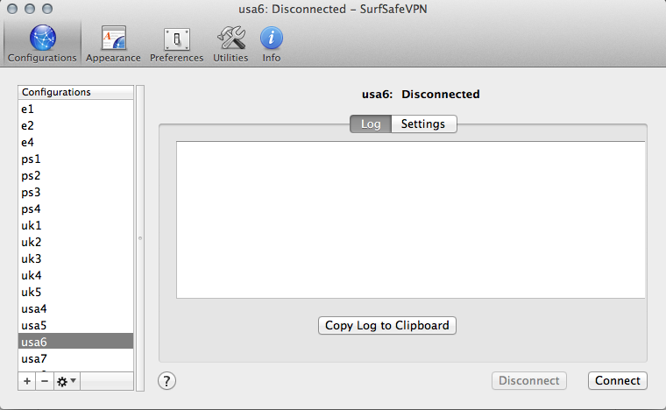
3. select server from the left panel
4. push connect button in the right bottom conner.
5. observe connection process (pic 3)
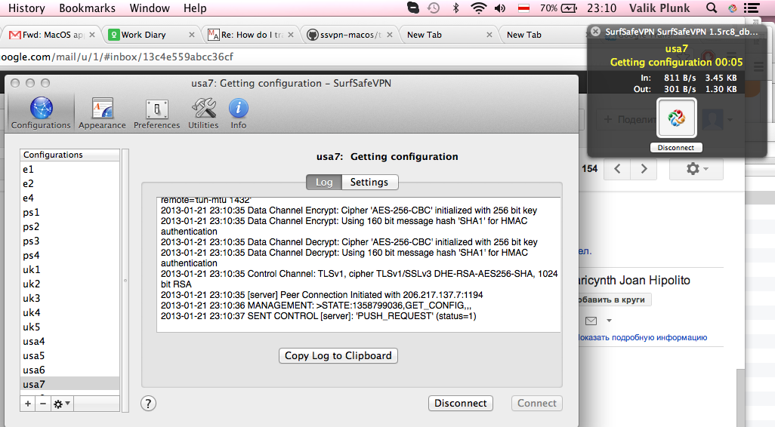

6. use "copy to clipboard" button and send complete log to my e-mail
7. Please don't try to use another functionality of "vpn details" window. It's deprecated and unstable functionality.
8. Send logs and screenshots to the support of SurfSafeVPN.

- Advanced logging
For some really specific failures you could check console system log
1. run Console system log (Applications->Utilities->Console)
2. select "All messages" on the top of left panel
3. write "kext" in the search field and press enter
4. select with shift and copy all log messages for today with cmd-c and paste it to the new text file with cmd-v (pic 0)
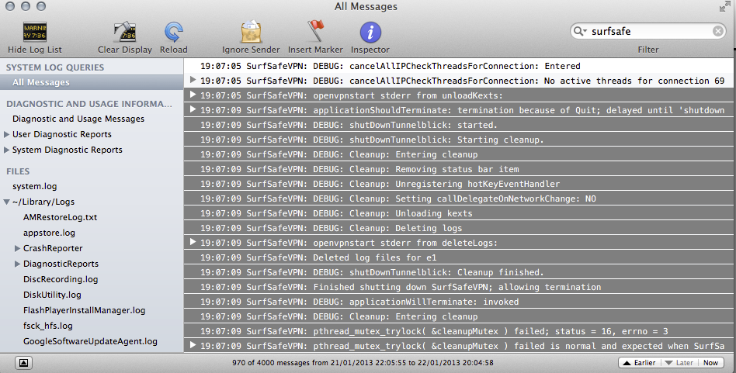
Send file to the SurfSafeVPN support.

